Log File

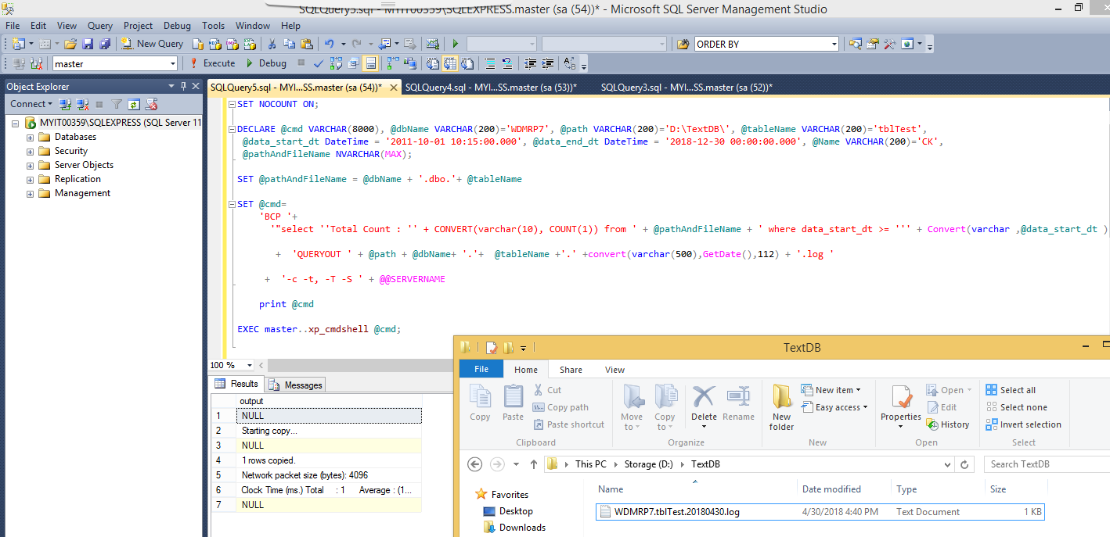

SET NOCOUNT ON;

DECLARE @cmd VARCHAR(8000), @dbName VARCHAR(200)='WDMRP7', @path VARCHAR(200)='D:\TextDB\', @tableName VARCHAR(200)='tblTest',

@data_start_dt DateTime = '2011-10-01 10:15:00.000', @data_end_dt DateTime = '2018-12-30 00:00:00.000', @Name VARCHAR(200)='CK',

@pathAndFileName NVARCHAR(MAX);

SET @pathAndFileName = @dbName + '.dbo.'+ @tableName

SET @cmd=

'BCP '+

'"select ''Total Count : '' + CONVERT(varchar(10), COUNT(1)) from ' + @pathAndFileName + ' where data_start_dt >= ''' + Convert(varchar ,@data_start_dt ) + ''' and data_end_dt <=''' + Convert(varchar ,@data_end_dt ) + '''" '

+ 'QUERYOUT ' + @path + @dbName+ '.'+ @tableName +'.' +convert(varchar(500),GetDate(),112) + '.log '

+ '-c -t, -T -S ' + @@SERVERNAME

print @cmd

EXEC master..xp_cmdshell @cmd;

Json File

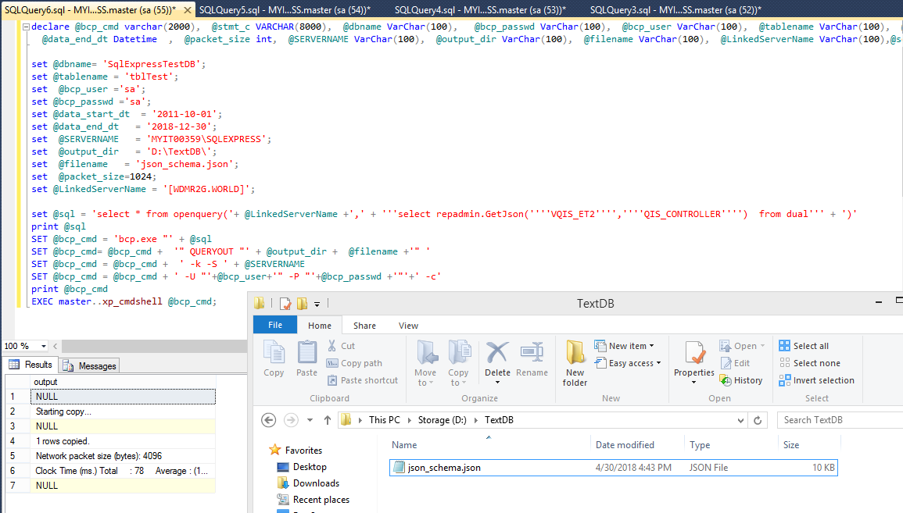

declare @bcp_cmd varchar(2000), @stmt_c VARCHAR(8000), @dbname VarChar(100), @bcp_passwd VarChar(100), @bcp_user VarChar(100), @tablename VarChar(100), @data_start_dt Datetime ,

@data_end_dt Datetime , @packet_size int, @SERVERNAME VarChar(100), @output_dir VarChar(100), @filename VarChar(100), @LinkedServerName VarChar(100),@sql varchar(2000);

set @dbname= 'SqlExpressTestDB';

set @tablename = 'tblTest';

set @bcp_user ='sa';

set @bcp_passwd ='sa';

set @data_start_dt = '2011-10-01';

set @data_end_dt = '2018-12-30';

set @SERVERNAME = 'MYIT00359\SQLEXPRESS';

set @output_dir = 'D:\TextDB\';

set @filename = 'json_schema.json';

set @packet_size=1024;

set @LinkedServerName = '[WDMR2G.WORLD]';

set @sql = 'select * from openquery('+ @LinkedServerName +',' + '''select repadmin.GetJson(''''VQIS_ET2'''',''''QIS_CONTROLLER'''') from dual''' + ')'

print @sql

SET @bcp_cmd = 'bcp.exe "' + @sql

SET @bcp_cmd= @bcp_cmd + '" QUERYOUT "' + @output_dir + @filename +'" '

SET @bcp_cmd = @bcp_cmd + ' -k -S ' + @SERVERNAME

SET @bcp_cmd = @bcp_cmd + ' -U "'+@bcp_user+'" -P "'+@bcp_passwd +'"'+' -c'

print @bcp_cmd

EXEC master..xp_cmdshell @bcp_cmd;

CSV File

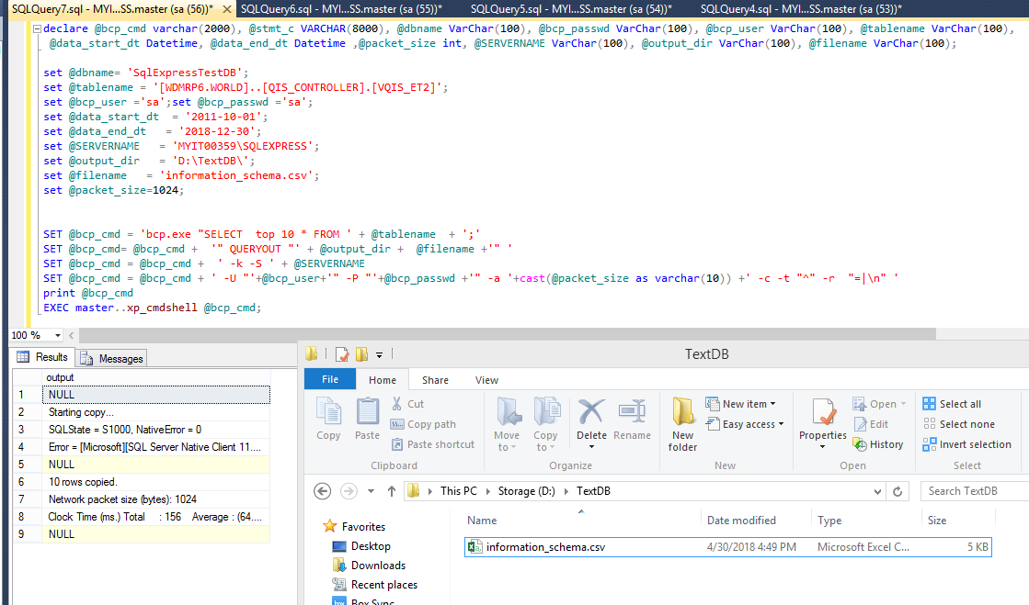

declare @bcp_cmd varchar(2000), @stmt_c VARCHAR(8000), @dbname VarChar(100), @bcp_passwd VarChar(100), @bcp_user VarChar(100), @tablename VarChar(100),

@data_start_dt Datetime, @data_end_dt Datetime ,@packet_size int, @SERVERNAME VarChar(100), @output_dir VarChar(100), @filename VarChar(100);

set @dbname= 'SqlExpressTestDB';

set @tablename = '[WDMRP6.WORLD]..[QIS_CONTROLLER].[VQIS_ET2]';

set @bcp_user ='sa';set @bcp_passwd ='sa';

set @data_start_dt = '2011-10-01';

set @data_end_dt = '2018-12-30';

set @SERVERNAME = 'MYIT00359\SQLEXPRESS';

set @output_dir = 'D:\TextDB\';

set @filename = 'information_schema.csv';

set @packet_size=1024;

SET @bcp_cmd = 'bcp.exe "SELECT top 10 * FROM ' + @tablename + ';'

SET @bcp_cmd= @bcp_cmd + '" QUERYOUT "' + @output_dir + @filename +'" '

SET @bcp_cmd = @bcp_cmd + ' -k -S ' + @SERVERNAME

SET @bcp_cmd = @bcp_cmd + ' -U "'+@bcp_user+'" -P "'+@bcp_passwd +'" -a '+cast(@packet_size as varchar(10)) +' -c -t "^" -r "=|\n" '

print @bcp_cmd

EXEC master..xp_cmdshell @bcp_cmd;

ZiP File

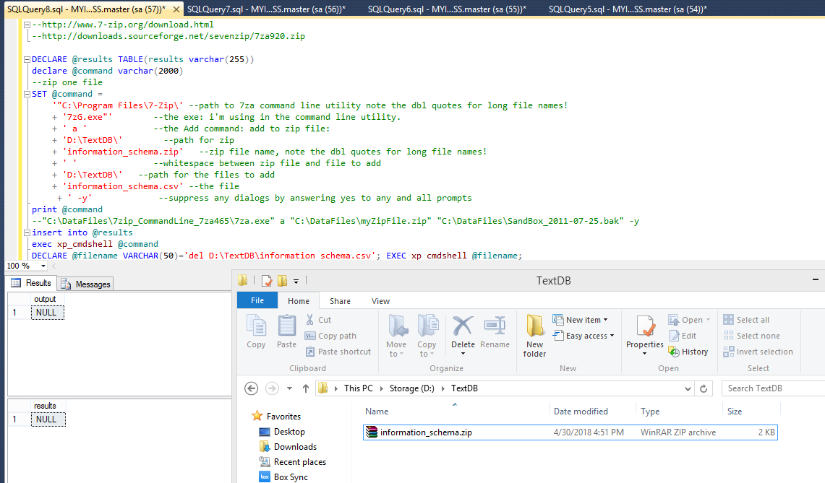

DECLARE @results TABLE(results varchar(255))

declare @command varchar(2000)

SET @command =

'"C:\Program Files\7-Zip\' --path to 7za command line utility note the dbl quotes for long file names!

+ '7zG.exe"' --the exe: i'm using in the command line utility.

+ ' a ' --the Add command: add to zip file:

+ 'D:\TextDB\' --path for zip

+ 'information_schema.zip' --zip file name, note the dbl quotes for long file names!

+ ' ' --whitespace between zip file and file to add

+ 'D:\TextDB\' --path for the files to add

+ 'information_schema.csv' --the file

+ ' -y' --suppress any dialogs by answering yes to any and all prompts

print @command

--"C:\DataFiles\7zip_CommandLine_7za465\7za.exe" a "C:\DataFiles\myZipFile.zip" "C:\DataFiles\SandBox_2011-07-25.bak" -y

insert into @results

exec xp_cmdshell @command

DECLARE @filename VARCHAR(50)='del D:\TextDB\information_schema.csv'; EXEC xp_cmdshell @filename;

select * from @results